Product Data Sheet ZP24-80-3
Serial # 1132.2-5
Thank you for your purchase of an Xradia zone plate optic. In this document you find the parameters and fabrication tolerances of the zone plate.

Zone Plate Parameters:
Outer Diameter | μm | 80
Inner Diameter (no zones) | μm | N/A
Outermost Zone Width | nm | 24
Zone Material |  | Electroplated Gold
Zone Height | nm | 300 +/- 8%
Number Of Zones² |  | 833
Suggested Energy Range³ | keV
Theoretical Max. Diffraction Efficiency¹ | %
Support Membrane Material |  | Si₃N₄
Support Membrane Thickness | μm | 0.1
Support Membrane Size | mm | 0.2 x 0.2
Support Silicon Frame Size | mm | 2 x 2
Central Stop Diameter⁴ | μm | NA
Central Stop Height / Material | μm | NA
¹ Xradia delivers zone plates with a focusing efficiency exceeding 50% of the theoretically calculated value.
² Number of fabricated rings calculated for a full zone plate (no missing inner zones).
³ Energy range for which the theoretical efficiency is greater 10%.
⁴ The placement accuracy of the stop is 10μm (typical 5 μm).

Zone Plate Focal Length
The focal length of the zone plate is given by:

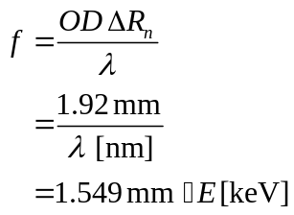

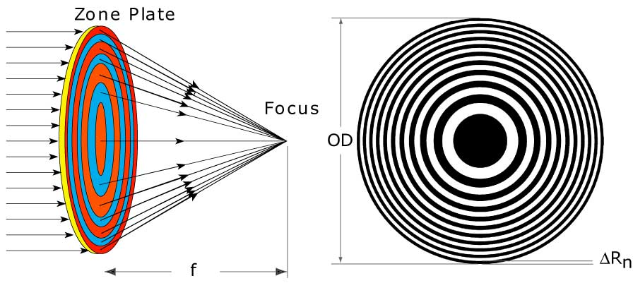
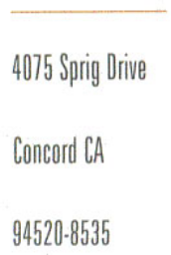


Product Data Sheet ZP24-80-3
Serial # 1132.2-5

Use In Vacuum
Zone plates can be used in vacuum. Several precautions need to be taken:
- No pressure differential can be applied between both sides of the zone plate wafer.
- Change the ambient pressure slowly. Avoid shocks generated by opening large conductance pneumatic valves.
- Zone plates can be damaged by ultra-sonic particles generated during venting of the vacuum system. Vent slowly and with a clean gas (use filter if possible). Avoid venting through a port which is in direct line-of-sight of the zone plate. Install a shield if necessary.
- Make sure that the zone plate heat load is small and removed through proper thermal connections. If in doubt, consult Xradia for advice.

SEM Micrograph

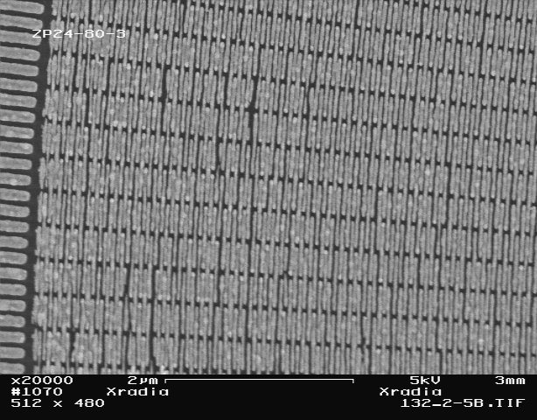

Outermost zones of the zone plate

